**Assignment No 3**

Q) Write a java program to create a database using an array and perform following operations on it: i. Add record ii. Display Database iii. Search record (binary search) iv. Delete record

INPUT:-

**import** java.util.Scanner;

**public** **class** Main

{

**public** **static** **void** main (String[]args)

{

Scanner scan = **new** Scanner(System.***in***);

EmployeeDatabase e1 = **new** EmployeeDatabase(5);

**boolean** cont = **true**;

**while**(cont)

{

**int** choice = 0;

System.***out***.println("1.Add Record: ");

System.***out***.println("2.Display Record");

System.***out***.println("3.Search Record");

System.***out***.println("4.Delete Record");

System.***out***.println("5.Exit");

System.***out***.println("Select the operation to perform: ");

choice = scan.nextInt();

System.***out***.println();

**switch**(choice)

{

**case** 1:

e1.addData();

**break**;

**case** 2:

e1.displayDatabase();

**break**;

**case** 3:

**int** id;

System.***out***.print("Enter Id of Employee: ");

id = scan.nextInt();

e1.Search(id);

**break**;

**case** 4:

**int** id1;

System.***out***.print("Enter Id of Employee: ");

id1 = scan.nextInt();

e1.delete(id1);

**break**;

**case** 5:

cont = **false**;

**break**;

**default**:

System.***out***.println("Enter valid option");

}

}

scan.close();

}

}

**class** EmployeeData

{

String name;

**int** id;

**double** salary;

}

**class** EmployeeDatabase

{

EmployeeData emp[];

**int** empNum = 0,currentEmp;

EmployeeDatabase (**int** empNum)

{

**this**.empNum = empNum;

emp = **new** EmployeeData[empNum];

**for** (**int** i = 0; i < empNum; i++)

{

emp[i] = **new** EmployeeData();

}

currentEmp = 0;

}

**void** addData ()

{

Scanner sc = **new** Scanner(System.***in***);

System.***out***.print ("Enter employee name: ");

emp[**this**.currentEmp].name = sc.nextLine ();

System.***out***.print ("Enter employee ID: ");

emp[**this**.currentEmp].id = sc.nextInt ();

System.***out***.print ("Enter employee salary: ");

emp[**this**.currentEmp++].salary = sc.nextDouble();

}

**void** displayDatabase ()

{

System.***out***.println();

System.***out***.println("Employee Data: ");

**for** (EmployeeData s:emp)

{

**if** (s.name != **null**)

{

System.***out***.println ("Employee Name: " + s.name);

System.***out***.println ("Employee ID: " + s.id);

System.***out***.println ("Employee Salary: " + s.salary);

}

}

System.***out***.println();

}

**void** Search(**int** id)

{

**boolean** found = **false**;

**for**(EmployeeData s: emp)

{

**if**(s.id == id)

{

System.***out***.println();

System.***out***.println ("Employee Name: " + s.name);

System.***out***.println ("Employee ID: " + s.id);

System.***out***.println ("Employee Salary: " + s.salary);

System.***out***.println();

found = **true**;

**break**;

}

}

**if**(!found)

System.***out***.println("Employee Record not found in database");

}

**void** delete(**int** id)

{

**boolean** found = **false**;

**int** loc = 0;

**for**(EmployeeData s: emp)

{

**if**(s.id == id)

{

found = **true**;

**break**;

}

loc++;

}

**if**(found)

{

**int** i;

**for**(i = loc; i < **this**.empNum - 1; i++)

{

emp[i] = emp[i+1];

}

emp[i] = **new** EmployeeData();

}

}

}

OUTPUT:-

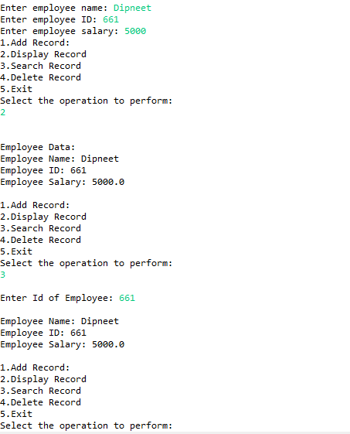

Name:- Yashraj Vijay Aware

PRN no:- 22110167

Roll No.:-224006

Div:-D

Div.:-D1